STAT 440
PROJECT INFO FOR MANUFACTURING DATA

INTRODUCTION
The manufacturing sector is a critical driver of employment, capital investment, and economic output. This report presents a statistical analysis of the Manufacturer dataset, which contains data on 140 manufacturing industries classified across 20 industry groups, with Standard Industrial Classification (SIC) codes ranging from 201 to 399. The dataset comprises nine variables capturing key dimensions of manufacturing performance, including the number of employees, value added by manufacturing, cost of materials, capital expenditure, and end-of-year inventory.
The primary objective of this analysis is to examine the distributional properties of key variables, explore relationships among them, and develop a predictive model for manufacturing value added. Both descriptive and inferential statistical methods are applied, with findings aimed at supporting data-driven business decision-making across the manufacturing sector.

METHODOLOGY
This analysis employs both descriptive and inferential statistical methods to examine the Manufacturer dataset. All computations and analyses were performed using the R statistical software environment. The dataset contains 140 observations across 20 industry groups, with nine variables capturing key dimensions of manufacturing performance. Before analysis, the data was inspected for missing values, duplicates, and anomalies. No missing values or duplicate records were found. The variable "Value of Industry Shipments" was identified as an ordinal categorical variable containing only four levels (1–4) and was treated accordingly throughout the analysis.

DESCRIPTIVE STATISTICS
Descriptive statistics were computed to summarise the central tendency, spread, and distributional properties of the key variables. Measures including the minimum, maximum, mean, median, and standard deviation were calculated for all continuous variables. Since Industry Group is a categorical variable, frequency counts and percentages were used to describe its distribution. Skewness and kurtosis were computed for Value Added and Number of Employees to assess departures from normality. Both variables exhibited strong positive skewness and high kurtosis, indicating right-skewed distributions with heavy tails and the presence of extreme values.

SUMMARY STATISTICS
 | SIC Code | No. Employees | No. Product Workers | Value added by Mfg | Cost of Materials | Value Added of Industry  Shipments | New Capital Expense | End-of-Year Inventory
Min | 201.00 | 1.00 | 1.00 | 34 | 71 | 1.000 | 1.0 | 17.0
Qua. 25% | 244.80 | 33.75 | 24.75 | 2683 | 2676 | 2.000 | 143.5 | 686.5
Median | 305.50 | 75.00 | 52.00 | 7534 | 7456 | 3.000 | 483.0 | 1498.5
Mean | 300.20 | 123.79 | 86.96 | 12498 | 14110 | 2.593 | 995.2 | 3050.8
Qua. 75% | 351.20 | 171.25 | 117.75 | 17888 | 16583 | 4.000 | 1154.2 | 3773.8
Max | 399.00 | 772.00 | 634.00 | 105899 | 223639 | 4.000 | 14345.0 | 36814.0
Standard Deviation | 58.41889 | 138.0624 | 102.1639 | 15340.69 | 24569.91 | 1.118172 | 1763.349 | 4242.622

Industry group is a categorical variable, so we compute it using :
- Frequency
- Percentage

SKEWNESS AND KURTOSIS
To examine the distributional properties of the key variables, skewness and kurtosis were calculated. Skewness captures the extent to which a distribution deviates from symmetry, while kurtosis measures the concentration of values in the tails relative to a normal distribution.
Value Added recorded a skewness of 2.92, indicating a strongly positive skew. This suggests that most manufacturing firms generate relatively low Value Added, while a small number of firms record extremely high values, pulling the distribution to the right. The corresponding kurtosis of 15.1 confirms that the distribution is heavily leptokurtic, exhibiting a sharp peak and very heavy tails. This strongly indicates the presence of extreme outliers and significant departure from normality.
Similarly, the number of Employees recorded a skewness of 2.33, also strongly positively skewed, meaning most firms are small in terms of workforce size, while a few employ a very large number of workers. The kurtosis of 9.76 further confirms heavy-tailed behaviour, consistent with the presence of a small number of unusually large manufacturing firms in the dataset.

DATA VISUALIZATIONS
Several visualisations were produced to support the descriptive analysis. A bar chart was used to display the distribution of Shipment Value categories across the dataset. A heatmap was constructed to examine the frequency of Shipment Value categories across industry groups, allowing for a visual comparison of shipment patterns. A box-and-whisker plot was used to compare Value Added across the 20 industry groups, providing insights into group-level differences, spread, and the presence of outliers.

Shipment_Value is an ordinal (grouped) variable, likely representing:
Value | Meaning (Typical)
1 | Low shipment level
2 | Moderate-low shipment
3 | Moderate-high shipment
4 | High shipment level

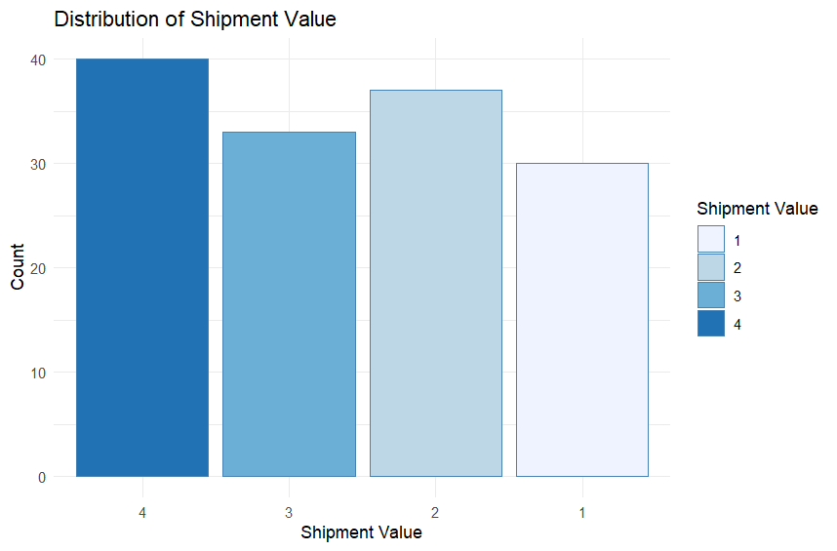
Shipment Value is an ordinal categorical variable coded into four levels representing increasing shipment magnitudes. A bar chart was used to display the distribution of firms across shipment value categories. The results indicate that Shipment Value Category 4 (highest shipment level) contains the largest number of firms, while Category 1 (lowest shipment level) contains the fewest. This suggests that a relatively greater proportion of firms fall within the higher shipment value ranges.

INTERPRETATION
The bar chart indicates that a larger proportion of industries fall within the highest shipment category (Category 4), suggesting that many industries operate at relatively high shipment levels. However, the presence of industries across all shipment categories indicates variability in production output among industries.

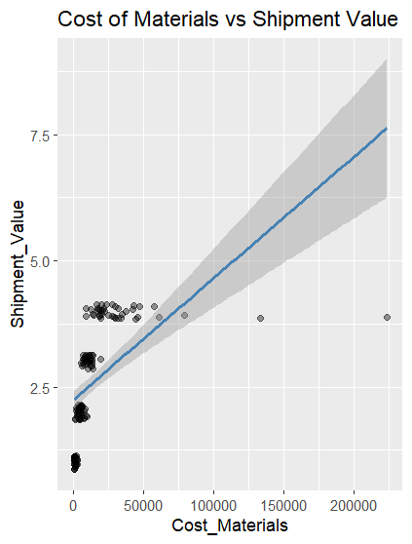
The scatter plot displays the relationship between Cost of Materials and Shipment Value categories. Each point represents an industry, while the horizontal axis represents the cost of materials used in production. Shipment Value is represented on the vertical axis as categorical levels ranging from 1 to 4. A fitted regression line is included to illustrate the overall trend between the two variables.

INTERPRETATION
The scatter plot indicates a moderate positive relationship between Cost of Materials and Shipment Value. Industries with higher material costs tend to fall into higher shipment categories, suggesting that increased material usage supports greater production output. However, the spread of points within each shipment category indicates variability among industries, meaning that material cost alone does not fully determine shipment level.

HEATMAP
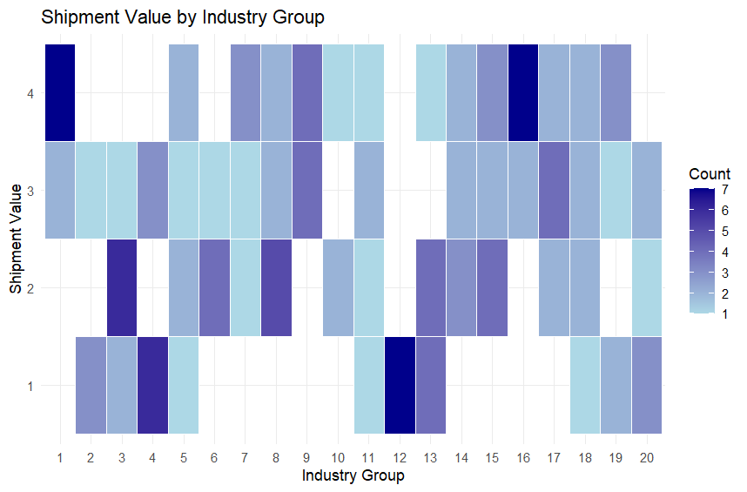
The heat map illustrates the distribution of Shipment Value categories across Industry Groups. Colour intensity represents the frequency of industries within each shipment category for a given industry group. Darker shades indicate higher concentrations of industries within specific shipment categories, while lighter shades indicate fewer industries. The variation in colour intensity across industry groups suggests that shipment levels differ among industries, indicating variability in production performance.

INTERPRETATION
Level 4 (highest shipment value):
- Group 1 and Group 16 are the darkest — both have the highest count (around 6-7) at the top shipment level, making them the dominant high-volume shippers

Level 3 (moderate-high shipment value):
- Group 17 stands out as notably dark here
- Most other groups have a light-to-medium presence at this level — shipment activity is fairly spread across groups.

Level 2 (moderate shipment value):
- Group 3 and Group 5 are clearly the darkest — confirming your earlier observation that Group 3 dominates at this level
- Several groups like 6, 9, 13 are white/missing at level 2.

Level 1 (lowest shipment value):
- Group 12 is unmistakably the darkest cell in the entire plot — by far the highest concentration at the lowest shipment level.

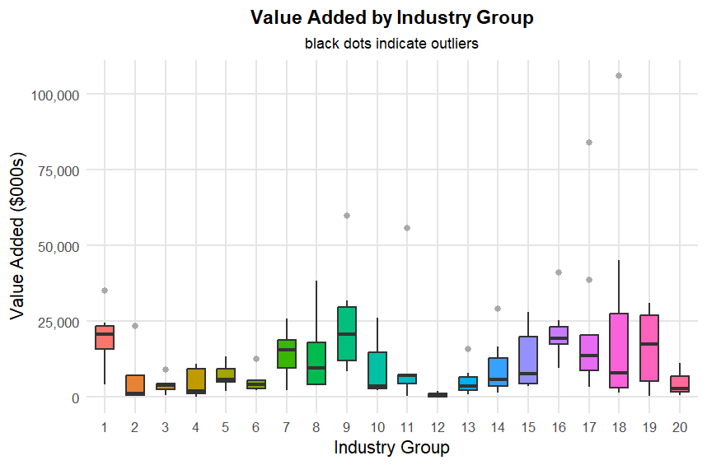

The box-and-whisker plot displays the distribution of Value Added ($000s) across the 20 manufacturing industry groups. Industry Groups 9, 18, and 19 record the highest medians, with Group 9 showing the widest spread, indicating high variability within that sector. Groups 1, 16, and 17 also perform strongly with relatively high medians. At the lower end, Groups 3, 12, and 20 consistently record the lowest medians and narrowest boxes, reflecting structurally low value generation. Notable outliers are observed in Groups 1, 9, 11, 15, 17, and 18, with Group 17 containing the most extreme outlier at approximately $105,000 ($000s), indicating the presence of exceptionally high-performing manufacturers within those sectors.

INTERPRETATION
- Groups 9, 18, and 19 are the most productive industry groups by Value Added — ideal targets for further investment
- Group 12 consistently underperforms — lowest median with almost no spread, suggesting structurally low value generation
- Group 17's extreme outlier warrants investigation — one manufacturer is vastly outperforming its peers within the group
- Group 11's outlier is interesting — despite a very low median, one manufacturer achieves exceptionally high Value Added, suggesting best practices worth studying
- The wide variability in Groups 9, 18, and 19 suggests unequal performance within those sectors — some manufacturers thriving, others struggling

REGRESSION MODEL
To identify the key drivers of manufacturing Value Added, a multiple linear regression model was developed. Given the strong positive skewness observed in the continuous variables, a log-log transformation was applied to all continuous predictors and the outcome variable. This approach stabilises variance, reduces the influence of outliers, and allows regression coefficients to be interpreted as elasticities — that is, the percentage change in Value Added associated with a one percent change in each predictor. Industry Group was included as a factor variable to control for sector-level differences. The final model took the following form:
log(Value Added) = β₀ + β₁log(Employees) + β₂log(Cost of Materials) + β₃log(Capital Expenditure) + β₄log(Ending Inventory) + βₖ(Industry Group) + ε
Model fit was assessed using the R², Adjusted R², and the overall F-statistic. Regression diagnostics, including residual plots, were examined to verify the assumptions of linearity, homoscedasticity, and normality of residuals.

Overall Model Performance
- R² = 0.9709 — the model explains 97% of the variation in Value Added. This is an exceptionally strong fit for manufacturing data
- Adjusted R² = 0.9651 — still very high after penalising for the number of predictors
- F-statistic p-value < 2.2e-16 — the model as a whole is highly statistically significant

Significant Predictors
Variable | Estimate | Interpretation
log(Num_Employees) | 0.495*** | A 1% increase in employees → ~0.50% increase in Value Added
log(Capital_Exp) | 0.198*** | A 1% increase in capital expenditure → ~0.20% increase in Value Added
log(Ending_Inventory) | 0.317*** | A 1% increase in inventory → ~0.32% increase in Value Added
log(Cost_Materials) | 0.027 | Not significant — surprisingly little direct effect on Value Added

Key insight: Num_Employees is the strongest driver of Value Added. Labour is the most important input in this manufacturing dataset.

RESULTS AND INTERPRETATION
The multiple linear regression model demonstrated an exceptionally strong fit, with an R² of 0.9709, indicating that the model explains 97% of the variation in Value Added. The Adjusted R² of 0.9651 confirms that this high explanatory power is maintained even after accounting for the number of predictors in the model. The overall F-statistic was highly significant (p-value < 2.2e-16), confirming that the model as a whole is statistically reliable.
Among the predictors, Number of Employees emerged as the strongest driver of Value Added, with a coefficient of 0.495, meaning a 1% increase in the number of employees is associated with approximately a 0.50% increase in Value Added. Ending Inventory followed with a coefficient of 0.317, and Capital Expenditure contributed a coefficient of 0.198, both statistically significant. Cost of Materials, however, was not statistically significant (estimate = 0.027), suggesting that material spending alone does not meaningfully drive manufacturing Value Added.

CONCLUSION
This report presented a comprehensive statistical analysis of the Manufacturer dataset, encompassing 140 manufacturing industries across 20 industry groups. Through the application of descriptive and inferential statistical methods, several key findings emerged with important implications for business decision-making.
The descriptive analysis revealed that manufacturing Value Added and Number of Employees are both strongly right-skewed with high kurtosis, indicating that a small number of large manufacturers dominate the sector while the majority operate at relatively low levels of output. This inequality was further confirmed by the box-and-whisker plot, which showed that Industry Groups 9, 18, and 19 are the highest performing groups by Value Added, while Groups 3, 12, and 20 consistently underperform. The heatmap analysis of Shipment Value across industry groups revealed that Groups 1 and 16 dominate high-volume shipments, while Group 12 is heavily concentrated at the lowest shipment level, reinforcing its position as the weakest performing sector.
The multiple linear regression model proved to be an exceptionally strong fit, explaining 97% of the variation in Value Added (R² = 0.9709). The results identified Number of Employees as the strongest driver of Value Added, followed by Ending Inventory and Capital Expenditure. Cost of Materials, surprisingly, was not statistically significant, suggesting that spending more on materials alone does not guarantee higher manufacturing output. Industry Group 2 emerged as the highest performing group relative to the baseline, while Groups 3, 4, and 5 significantly underperformed.
From a business perspective, these findings suggest that manufacturers seeking to increase value added should prioritise workforce investment and capital expenditure over material costs. Industry Groups 9, 18, and 19 represent the most productive sectors and warrant further investment, while Groups 12 and 3 may benefit from operational restructuring to improve their value generation capacity.

